The thirty-minute guide to Private Equity





Specially commissioned by UNI Global Union
Written by Andrew Bibby
Foreword

UNI Global Union continues to advocate respect for labour rights with the alternative financial asset classes in a period of significant change for financial markets. Private equity and hedge fund assets are feeling the pressure of their creatively crafted debt arrangements. The fact remains however that they still own portfolio companies which have millions of people in employment.

UNI Global Union is concerned about what the deteriorating financial environment means to the debt laden companies. The protection of workers interests during this credit crisis is a serious concern and not one likely to be born by the companies or their investors. None of these funds have made a commitment to a labour code which embraces the workers of a company they have invested in.

Alternative assets are under the global microscope and many governments and world bodies have decided to examine their impact on taxation, regulation, transparency and workers rights. At a national level capital strategies are being debated around the world and drawing increased public attention. UNI has played a significant role in raising the debate to this level and continues to remain active within it.

UNI has developed this simple ‘30 minute guide to private equity’ to assist to make sense of the complexities of this capital strategy and its impact on workers. The guide is intended for affiliates to circulate to officials and members alike, to raise awareness and encourage organising of employees employed by private equity companies and indeed those who are subject to a take over in the future.

Philip J. Jennings
UNI Global Union General Secretary



This report should take you no more than thirty minutes to read. By the end, you will know why private equity companies represent a major risk to workers’ jobs and employment conditions around the world – and why trade union organisations like UNI are campaigning for proper controls over this multi-billion dollar industry.

1: The rise of private equity funds

In the past few years, billions of dollars have been invested in companies by private equity funds. These funds aren’t invested, in the traditional way, in shares traded on stock markets: they are used to buy up whole companies, and then take them ‘private’.

This means that companies no longer have their shares traded publicly. Instead, they are completely under the control of the investment fund.



11/2006: global unions launch campaign to drive Private Equity out of the shadows

2: What private equity funds do

Private equity funds look for extremely high financial returns in the very short term. To achieve this means squeezing as much money from the business as possible, by selling off assets, piling up debts and cutting costs – including, often, making savage cuts in staff.

Private equity funds are not concerned with the medium- or long-term development of the company, or with investing for future growth. Their approach reduces successful businesses (and the workers) to the status of being nothing more than a bundle of assets, there to generate short-term financial gains.

3: Private equity: low-profile but highly influential

Until very recently, private equity funds worked in the shadows and attracted very little public or media attention.

Nevertheless, the size of the industry is enormous. Household brands such as Burger King and Hertz are, or have been, subject to private equity buy-outs. The former nationally owned Danish telecom company TDC is now in the hands of private equity. Private equity funds have tried to acquire the Australian airline Qantas and the UK supermarket chain Sainsbury’s.

In 2007, private equity funds between them invested hundreds of billions of US dollars.

4: Where the money comes from

The largest single source of the massive amount of money invested in private equity funds are pension funds, who are looking for higher than usual returns.

Banks and insurance companies are also big investors. Money also comes from very rich individuals.

Pension fund investment raises inevitable concerns that, if anything goes wrong in the future, money put aside for workers’ retirement incomes is potentially at risk.



01/2007: Private Equity on the agenda at the World Economic Forum in Davos

5: Why private equity can afford to buy major global companies

It’s been said that almost any company, no matter how big, could be the target of a buy-out by a private equity fund.

This is because of the way take-overs are financed. Only a small percentage of the cost of buying a company is financed by private equity funds’ own money. The rest of it (typically 75%-85%) comes from money borrowed, for example from big banks.

This process is called ‘leveraging’. Just as a lever allows a small amount of energy to move a heavy weight, so private equity funds leverage in extra borrowings so that their own money goes much further.

Once the take-over is complete, the target business is restructured so that these new debts become the debts of the company itself. In this way, companies which are victims of equity fund take-overs are actually made to finance the take-overs themselves.

Some say that this is equivalent to a street robber asking you to beat yourself up, as they make off with your money.

 Almost any company, no matter how big, could be a PE buyout target

6: Increasing a company’s ratio of debt

Traditionally, companies have tended to prefer to have most of the capital they need through equity capital (money from shareholders) rather than as debt capital, such as loans. This is because interest has to be paid on loans, directly eating into the ability of a business to be profitable.

Private equity funds reverse the usual equity/debt ratio. Companies taken over by private equity funds tend to be burdened by very high debt levels. Money which could be used for expansion or for developing new products is diverted to pay the necessary interest.

7: Borrowing more to increase the financial pay-outs

Companies are weighed down not only by the debt taken out in order to finance the original private equity take-over. Another ploy is to borrow yet more money, simply to make enormously large dividend payments to the business’s new owners.

What happens is that money which comes in to the company from new loans is paid straight out again in dividends. (This device is given the impressive sounding name of dividend recapitalisation.)

Traditionally, companies have borrowed to invest for the future – to put resources, perhaps, into research and development or to re-equip with new technology. But borrowing to pay big dividends does nothing for the long-term future of the company.

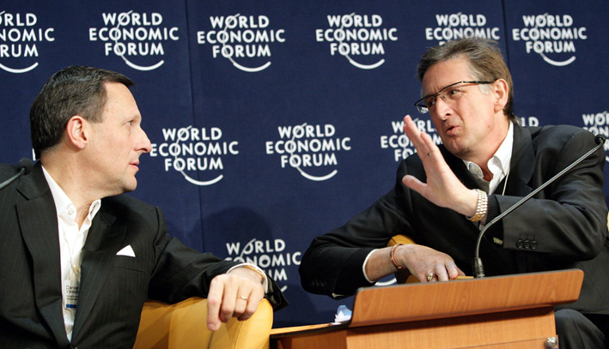

01/2007: UNI General Secretary Philip Jennings puts Private Equity in the headlines

8: Turning assets into ready money

There are other ways in which private equity investors can maximise the returns they get.

One approach is to sell off a company’s accumulated asset base. For example, properties and land-holdings may be sold off, so that the money realised from these sales can also be passed across to the investors. One approach is ‘sale and lease back’: a company sells its properties, and then leases them back from the new owner.

This approach weakens a company in the longer-term, but produces more cash in the short-term for distribution.

9: Bringing in their own management

Once a business has been taken over, private equity funds usually bring in their own senior management teams. Their job is straightforward: to maximise the opportunities for short-term returns.

One way is to try to reduce expenditure. This often means attempting to reduce the numbers of workers employed, and to worsen the pay and conditions of those that remain.

In a now notorious example from London’s Heathrow airport, Gate Gourmet tried to replace better paid unionised staff with poorer paid non-unionised workers.

Private equity management can be associated, therefore, with attempts to renege on existing agreements and to destroy a social partnership approach to industrial relations.

Even if these sorts of changes can be resisted, the short-termism associated with private equity has other implications for workers. For example, there is no incentive any more to invest in staff training and development.

02/2007: UNI warns of global threat of Private Equity

10: And who is really in charge?

Private equity funds say that they are simply the investors and it is not their role to negotiate with unions.

But too often this is a convenient fiction: behind the scenes, private equity funds are pulling the strings, leaving company managements with only limited authority.

In an industrial dispute in Germany, for example, (again concerning Gate Gourmet) a compromise agreement was unilaterally vetoed by the private equity owner of the company, going over the head of the firm’s management.

11: There are knock-on effects, too

Because even large, successful businesses may potentially be at risk of a take-over by private equity finance, as a defence mechanism they may begin to act in the same way.

They too can adopt the approach of maximising short-term profits and shareholder dividends, and of reducing long-term investment.

In the same way as one rotten orange can quickly spoil a whole box, so private equity’s ways of operating can spread to the rest of the economy.

 03/2007: UNI meets Blackstone PE group in the USA

12: Secrecy

By taking companies ‘private’, private equity funds avoid the need to make information about them public. There is no longer for the extensive reporting obligations which public companies normally have to abide by. A shroud of secrecy falls over the inner workings of the businesses.

13: Can private equity have positive results?

Private equity companies sometimes claim that they help to create jobs.

It’s true that private equity can also be invested as venture capital to help new businesses become properly established, or to provide additional resources for young businesses wanting to expand. This sort of investment can indeed help stimulate enterprise and employment (although venture capital is still very short-term, and can discourage a slow-but-steady approach to business growth).

Only about 5%-10% of private equity investment in Europe in 2005 was this sort of venture capital. By contrast, the sort of ‘leveraged’ buy-outs of existing companies described in this booklet took about 70% of the total invested.

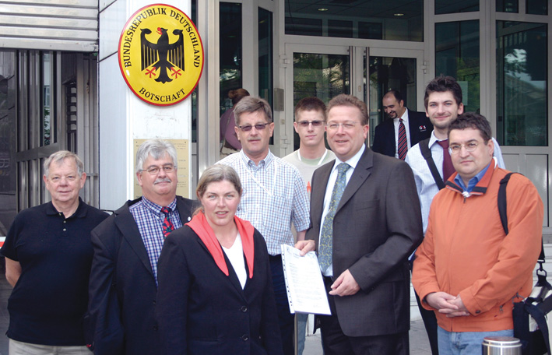

05/2007: Protest over job losses at Deutsche Telekom after the arrival of a PE shareholder

14: Private equity operates worldwide

Private equity funds focused initially on countries such as the US and UK. It has been estimated that 20% of private sector employees in the UK now work for companies which are owned by private equity.

It is not only English-speaking countries which are affected, however. In France, almost one in ten private sector workers are in private equity-owned businesses.

Private equity is now at work in other economies. Companies in countries such as Japan, South Africa, Argentina, Brazil and Poland have been taken over. India is experiencing a surge of private equity investment.

15: Public services are a tempting target

Private equity funds are attracted to companies which have relatively stable earnings and cash flows – in other words, ‘cash cows’ which can be milked for all that they have.

Utilities supplying services such as electricity and gas and telecoms frequently meet these criteria. Private equity pressure can intensify international moves, which have seen public services being turned into private profit-generating businesses.

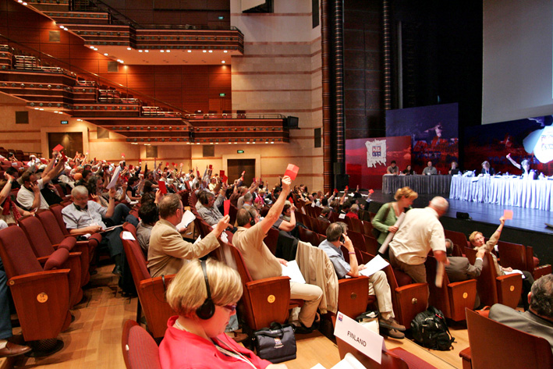

05/2007: UNI-Europa conference in Athens hears of brutal pension cuts following PE takeover

16: Which way is the exit?

The private equity investment model is based on very short-term time periods. The idea is to invest, make money, and then sell quickly, moving the money on to the next company to be acquired.

Private equity funds normally plan their exit strategy at the same time as they plan the acquisition. The usual route is either to turn the company back into a public company again, by holding a share flotation, or to sell it on to a second private equity investor.

The period of investment is short: five years is a long time for a private equity fund to own a business; two or three years is considered much more satisfactory.

This means that ownership of some businesses can pass through several different private equity funds in a matter of a few years.

17: Looking for the big returns

The investors (including pension funds) who choose to invest in private equity funds do so because the returns appear to be much better than those available from shares and other investments.

Certainly, the returns on some funds seem to have been spectacular. Private equity funds frequently claim returns of 20%-25% or even more.

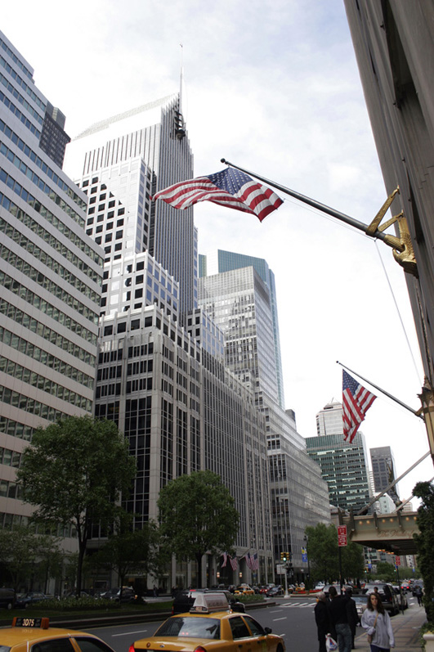

UNI meets PE groups in US, UK and France - US and Japanese unions set up PE task forces

18: Advisers do well, too

To take a company ‘private’ requires professional advice from, among others, merchant banks and commercial law firms.

These advisers receive significant fees for their services, money which ultimately comes from only one source: the business which is being taken over.

19: The private equity fund companies

The really big returns in the private equity industry, however, are enjoyed by the companies who actually set up and manage the funds.

For example, the private equity takeover of Hertz brought the private equity company behind it a return of 128% in less than a year. Another private equity company made 368% in seven months from the German chemical company Celanese.

Typically, private equity companies charge investors an annual ‘management fee’ of 2%. They also reward themselves with a large single payment at the end, when the private equity fund sells on the company it has purchased and heads for the exit. This single payment, based on profits generated by the fund, is usually set at 20%.

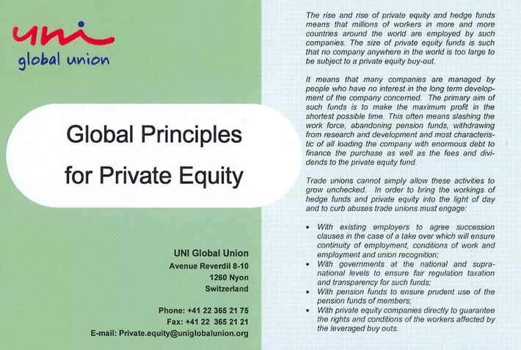

09/2007: UNI launches 11-point plan to build global principles for Private Equity
In Britain the TUC warned of the threat to investment in Telecom caused by PE buyouts

20: Who are these companies?

The companies behind the takeovers of Hertz and Celanese, mentioned above, were Carlyle and Blackstone, two of the largest private equity management firms.

Other major private equity firms include Bain Capital, TPG (Texas Pacific Group), KKR (Kohlberg Kravis Roberts) and Permira. There are several other major players. UNI US affiliate SEIU has calculated that, between them, the top twenty indirectly employ four million people. London is a favourite base for private equity.

The individuals behind these companies have become enormously wealthy. The two people who set up Blackstone, for example, received $398 million and $212 million respectively in 2006 alone: in 2007 (and perhaps somewhat ironically) they took their company public by selling shares in it, a process netting them an estimated $2.5 billion more.

21: Getting round the tax rules

Despite the enormous profits they make, private equity companies have been adroit in paying very little, or no, tax.

There are various reasons for this. Firstly, in several countries they benefit from tax breaks originally designed to encourage genuine investment in new businesses and business expansion.

When private equity funds sell the companies they have taken over, the returns they make can usually be treated as capital gains, not income. Capital gains are typically taxed at a much lower rate than income.

The companies which pass into the ownership of private equity funds also typically pay much less corporation tax than they would otherwise have done. This is because they have to pay interest on all the new debt they have been burdened with and these interest payments are tax-allowable, reducing their taxable profits.

Finally, private equity funds are normally conveniently based ‘offshore’, in low-tax countries.

Growing union anger at job losses and attacks on workers’ conditions as PE buyouts boom

22: The risk to social welfare

Finding ways round the tax laws increases still further the financial returns enjoyed by private equity firms and investors. However, particularly now that private equity ownership is extending to very large companies, society as a whole is suffering from the significant decline in the amount of money being paid by businesses in tax.

Governments need tax revenue to fund their welfare services. An economy dominated by private equity is one where the welfare state is increasingly at risk.

23: More on those company debts

As already mentioned, when a private equity fund purchases a company the bulk of the money needed comes in the form of borrowings, usually from banks.

These loans are being turned back into investments in their own right, by being parcelled up together by the banks and sold in the financial markets. (This process is known as ‘securitisation’). It was the securitisation of poor quality US mortgage loans which led to international banking difficulties in 2007.

Many of the loans made as part of private equity buy-outs have been securitised. No-one really appears to know where these loans have ended up.

This doesn’t concern the markets when things are going well. Now the international financial outlook is changing, there may be worrying consequences for the stability of financial institutions and banks.

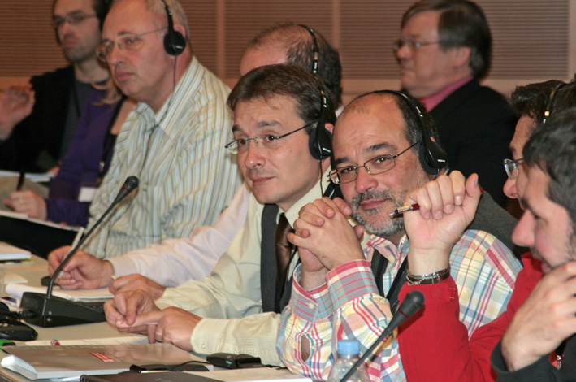

11/2007: Second global union conference on PE looks at the negotiating agenda

24: Private equity and hedge funds

All this is part of a wider trend in recent years to invest not in businesses themselves, but in financial products one level – or several levels - removed from the actual underlying assets on which they are based. (These sorts of investments are known generically as derivatives.)

Private equity is often linked to hedge funds, a wide category of investment funds seeking high returns (often by investing in derivatives of various kinds) but also taking high risks.

Some hedge funds buy the securitised loans associated with private equity takeovers of companies. Hedge funds also intervene by buying and selling company shares, not necessarily because of the strength or weakness of the companies but according to an assessment of how likely they are to be private equity targets. Hedge funds are playing an increasingly key role in acquisitions, as for example in the recent battle for Dutch bank ABN AMRO.

25: How long will the money keep flowing?

It is not clear that the private equity firms can continue to deliver very high returns for more than a short period of time. There is a limit to the ability to squeeze ready money out of company assets.

There have been suggestions that, in any case, the private equity industry has been hyping its overall success rate: private equity funds, which fail and go under don’t necessarily show up in the overall statistics for the sector.

As the world economy falters, the ‘golden’ years for private equity firms may now be coming to an end.

What happens after the private equity bubble bursts? What happens to the businesses which have experienced the short-term asset-grabbing private equity approach?

12/2007: Researches in England and by WEF confirm that PE buyouts destroy jobs

26: A real risk to the financial system

Private equity is not about value creation. It turns the real economy into something which is simply the backdrop for clever financial juggling acts.

Both private equity and hedge fund investment is driven by a desire to find apparently easy money. But the risks are carried by all of us.

Perhaps the most serious risk is to the stability of the whole financial and banking system on which the world’s economy is based.

27: Turning the tables by organising

Collectively, through trade unions, something can be done about private equity.

A well-organised workplace is a shield against the worst excesses of private equity. The stronger the union presence within a company, the more likely it is that private equity funds will find it harder to effect a takeover or asset-strip a business.

Unions can also work with pension fund trustees, pointing out to them that private equity represents a high risk investment strategy. A pension fund investment in a private equity fund may also directly or indirectly damage the prospects and security of employees who are themselves pension fund members.

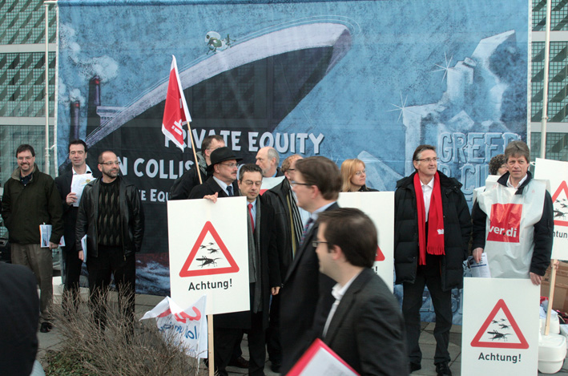

03/2008: UNI challenges PE operators with greed at their Munich gathering

28: Lobbying for regulation change

Thanks in large part to trade unions the spotlight has at last began to shine on private equity funds and their operations.

Union pressure has already put private equity funds on the defensive. Effective lobbying at national and international level is beginning to encourage stronger regulatory oversight of private equity fund activities. A number of countries are reviewing the favourable tax regimes enjoyed by private equity.

To take the heat off, the private equity industry is moving towards introducing their own codes of practice. This sort of self-administered voluntary regulation is not adequate, however. The operations of private equity companies need to be at least as visible and transparent as the activities of public listed companies.

29: Bringing private equity to the negotiating table

UNI and other unions have called for private equity companies to acknowledge their responsibilities towards the employees who work in the companies they own. It is not acceptable for private equity companies to maintain the fiction that they are simply investors with no influence over the management of the business.

Private equity companies should commit to ensuring that the companies they own abide by core labour standards. They should also meet the standards established by the ILO Multinational Enterprises Declaration and the OECD Guidelines on Multinationals.

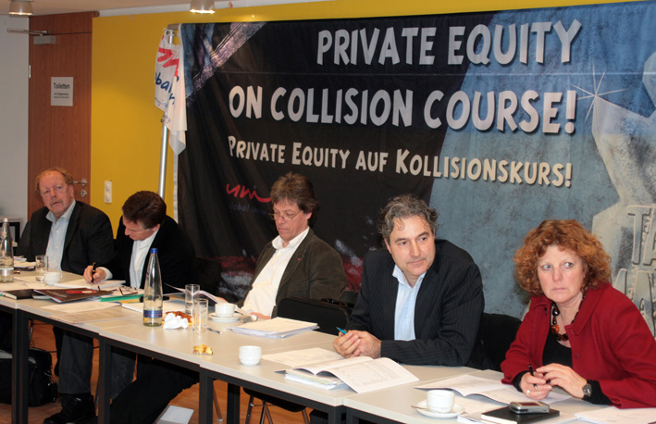

03/2008: UNI Press conference in Munich calls for standards to defend workers in PE buyouts

30: Global principles for private equity

UNI has drawn up an eleven-point set of Global Principles for private equity.

The principles call for the value which comes from a successful company to be shared between all who have a stake in the business.

For customers there should be a commitment to maintaining good quality services and products.

For owners, there should a fair and reasonable return on investment through increasing efficiency and productivity.

For employees, there should be protection of wages and conditions, decent work and fair treatment free from discrimination.

Got more time? Want to learn more about the problems of private equity?

UNI has dedicated part of its website to issues about private equity:
http://www.uniglobalunion.org/uniindep.nsf/privateequity?openpage

UNI affiliate SEIU has produced an excellent guide, Behind the Buyouts. This, and more news about private equity, can be found at:
http://www.behindthebuyouts.org/

The ITUC report Where the House always Wins: Private equity, hedge funds and the new casino capitalism can be found via UNI’s website or direct at:
http://www.ituc-csi.org/IMG/pdf/ITUC_casino.EN.pdf

The IUF Global Union report A Workers’ Guide to Private Equity Buyouts (available in several languages) can be found via a link on UNI’s website or direct at:
http://www.iuf.org

A comprehensive report Hedge Funds and Private Equity: A Critical Analysis has been produced for the PSE (Socialist Group in the European Parliament):
http://www.socialistgroup.eu/gpes/media/documents/33841_33839_hedge_funds_executive_summary_070329.pdf

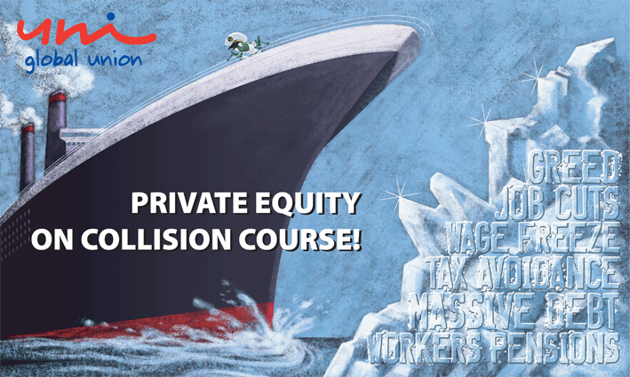

03/2008: UNI banner warns of collision course

1

03/2008: ver.di highlights the threat from ‘locusts’ - the name given in Germany to hedge funds

(Photos: UNI, WEF and Rod Leon)

